RELIABILITY, AVAILABILITY, MAINTAINABILITY, AND COST (RAM-C) RATIONALE REPORT

OUTLINE GUIDANCE

Version 1.0

The following RAM-C Report outline was prepared by Department of Defense (DoD) Engineering for use by DoD acquisition programs. The outline includes guidance and expectations regarding appropriate details to include in each section.

The program may use this document as a template or establish a RAM-C Report template that includes the recommended content.

Please direct questions or comments to the Office of Primary Responsibility:

Deputy Director for Engineering
3030 Defense Pentagon
3C160
Washington, DC 20301-3030

E-mail:
osd.pentagon.ousd-re.mbx.communications@mail.mil
Attn: Engineering/RAM

Distribution Statement A. Cleared by DOPSR, Case # 17-S-1312. Distribution is unlimited.

This page is intentionally blank.

Reliability, Availability, Maintainability, and Cost (RAM-C) Rationale Report

Month dd, yyyy

Program Name – ACAT Level

RAM-C Rationale Report
Version ___

Attached To Program Name System Engineering Plan
Supporting Milestone _
and
[Appropriate Phase Name]

SEP Dated Month dd, yyyy, SEP Version Xx

*************************************************************************************

SUBMITTED BY

_________________________  Name  Lead Systems Engineer | ____________  Date | __________________________  Name  Product Support Manager | ___________  Date
_________________________  Name  Business Financial Manager | ____________  Date | __________________________  Name  Program Manager | ___________  Date

concurrence

_________________________  Name  Program Executive Officer or Equivalent | ____________  Date

component approval

_________________________  Name  Title, Office | ____________  Date

Expectation: The RAM-C Rationale Report should be attached to the SEP and approved at an appropriate level as determined by the program office.

Contents

- Executive Summary
  - Sustainment KPP Assessment
  - Summary
- Introduction
  - Purpose
  - Changes
  - Preparers
- Program Information
  - System Description
  - Sustainment Parameters
  - OMS/MP
  - Maintenance Concept and Planning Factors
- Validation
  - Operational Availability (A_{O})
  - Materiel Availability (A_{M})
  - Reliability
  - O&S Cost
  - Summary
- Feasibility
  - Composite System Model
  - R&M Feasibility
  - O&S Cost Feasibility
  - A_{O} and A_{M} Feasibility
  - Feasibility Summary
- Trade Studies
- Summary

Annex A – Acronyms
Annex B – Documentation, References, and Tools
Annex C – Composite Model Details

Tables
Table 1.1-1 Sustainment KPPs
Table 2.2-1 RAM-C Update Record
Table 2.3-1 RAM-C Preparers and Organizations
Table 3.2-1 Sustainment Parameters
Table 3.3-1 Operational Mode Summary
Table 3.3-2 Summary of Environmental Data
Table 4.1-1 A_{O} Validation
Table 4.2-1 A_{M} Validation
Table 4.3-1 O&S Cost Validation
Table 5.2-1 R&M Feasibility
Table 5.3-1 O&S Cost Feasibility
Table 5.4-1 A_{O} and A_{M} Feasibility
Table B-1 Resource Documents
Table B-2 RAM-C Tools
Table C-1 Composite Model Details

Figures
Figure 6-1 Relationship Between Sustainment Parameters and Cost

Executive Summary
Expectation: The information for the Executive Summary is obtained from the body of this document. The purpose from Section 2.1 (Purpose) is entered here.

Sustainment KPP Assessment
Expectations: The list of Sustainment Key Performance Parameters (KPPs) and supporting Key System Attributes (KSAs) and Additional Performance Attributes (APAs) and their values should be extracted from Table 3.2-1 (Sustainment Parameters Table). The Composite Model Estimate of the new system and Predecessor (Legacy) System values should be obtained from Section 5 (Feasibility). Identify and discuss any thresholds that are not feasible e.g., the mission reliability estimate shown in red.
Table 1.1-1 Sustainment KPPs (sample aviation parameters and values based on continuous usage)
Draft CDD, CDD or CPD |  |  | Feasibility Results
Parameter |  | Threshold | Composite Model  Estimate | Predecessor (Legacy)  System
KPP | Materiel Availability | 0.65 | 0.67 | 0.58
KPP | Operational Availability | 0.80 | 0.80 | 0.73
KSA | Mission Reliability | 46 | 40 | 18
KSA | Logistics Reliability | 3.5 | 4.2 | 2.5
APA | Maintenance Burden | 9.0 | 8.0 | 15
APA | Corrective Maintenance | 0.5 | 0.5 | 1.0
KSA | O&S Cost | $423.7M | $471.4M | $722.6M

Summary
Based on the detailed analysis conducted in the body of this document, summarize whether the Joint Capabilities Integration and Development System (JCIDS) sustainment parameters are validated and feasible. Identify any significant issues in the Operational Mode Summary/Mission Profile (OMS/MP), failure definitions, or Maintenance Approaches. Identify any issues with specific sustainment parameters and associated recommendations provided to the requirements developers or other stakeholders. For updates to the RAM-C at the RFP Release Decision Point, MS B, and MS C summarize notable program changes that influenced the outcomes of the RAM-C analysis. Provide the results of trade study to illustrate the acceptable region for R&M parameters consistent with the A_{O} and Operations and Support (O&S) cost thresholds.
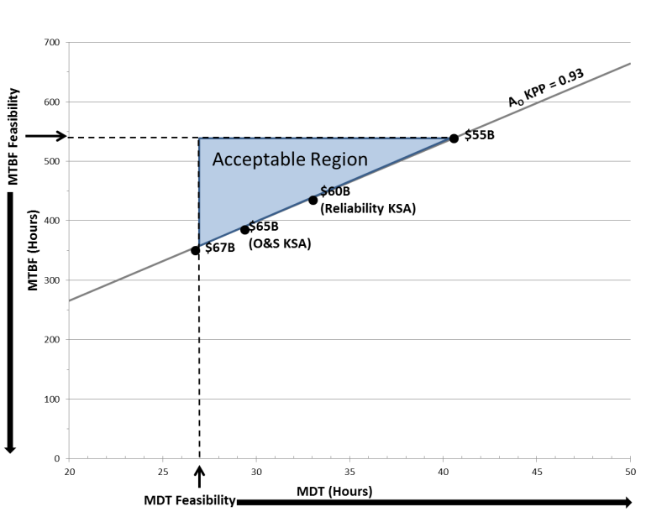
Expectation: If significant issues are discovered during the development of this report, the program should work with the cognizant Requirements Developer, JCIDS Requirements Manager, DCAPE, and other DoD Component to resolve them before the report is submitted for approval. Summarize any remaining significant issues from sections 3.2 (CONOPs and OMS/MP), 3.3 (Maintenance Concept and Planning Factors), 4 (Validation), and 5 (Feasibility). Illustrate the trade study conduct in section 6. For recommendations to specific sustainment parameters, refer to section 7.

Figure 1-1 Relationship Between Sustainment Parameters and Cost (sample)

Introduction

Purpose
Provide a brief overview of the purpose of this version of the report and the JCIDS documentation (i.e., Draft Capability Development Document (CDD), CDD, or Capability Development Document (CPD)) that it supports.
Expectations: The RAM-C Rationale Report should provide a quantitative basis for reliability, availability, and maintainability requirements, as well as improve cost estimates and program planning. RAM-C rationale reports are to be developed and attached to the SEP at MS A, RFP Release Decision Point, MS B, and MS C.

Changes
List changes to the RAM-C in Table 2.2-1 since the last update or indicate that this report is the initial release. The RAM-C may be updated due to changes in supporting documents i.e., changes to the OMS/MP or JCIDS documentation (user requirements).
Table 2.2-1 RAM-C Update Record
Revision Number | Date | Description of Changes | Approved By
001 | 1/1/15 | Updated OMS/MP required a re-assessment of mission reliability | XYZ

Preparers
List the RAM-C Rationale Report preparers in Table 2.3-1. Add additional rows if needed.
Table 2.3-1 RAM-C Preparers and Organizations
Function | Preparer | Organization
R&M Engineer | Name | Organization Name and Code
Product Support Specialist | Name | Organization Name and Code
Cost Analyst | Name | Organization Name and Code

Program Information
Expectation: Section 3 (Program Information) provides the data and information needed to develop the rationale that program’s sustainment parameters are valid (Section 4) and feasible (Section 5). As part of the process for developing the report, provide a list of acronyms in Annex A and a list of references in Annex B.

System Description
Using the reference design concept from or that will be in the Acquisition Strategy, identify major subsystems that are subject to R&M requirements. The system description should be user-oriented and operational and should include all elements of the system, including Government-furnished and contractor-furnished hardware (whether developmental or not), system software, operating and support documentation, and the crew and maintainer personnel.

Sustainment Parameters
In Table 3.2-1, list the sustainment parameters as stated in the JCIDS documentation (Draft CDD, CDD, or CPD). During the MSA Phase, the data gathering should begin as soon as preliminary inputs are available from the (user) e.g., from working versions or informal review of the Draft CDD.
Include the source of the sustainment parameters. For example: The sustainment parameters, definitions, and thresholds with units in Table 3.2-1 were obtained from the Program Name Draft CDD version xx, dated Month dd, yyyy.
Table 3.2-1 Sustainment Parameters (sample aviation parameters and values based on continuous usage)
Parameter¹ |  | Definition (samples) | JCIDS Threshold | Units
KPP | Materiel Availability | Measure of the percentage of the total inventory of a system operationally capable, based on materiel condition, of performing an assigned mission. | 0.65
KPP | Operational Availability | Measure of the percentage of time that a system or group of systems within a unit are operationally capable of performing an assigned mission e.g. uptime/(uptime + downtime). | 0.80
KSA | Mission Reliability |  | 46 | Hours
KSA | Logistics Reliability | Total number of items removed from the aircraft that cause a demand to be placed on the supply system divided by the total number of flight hours. | 3.5 | Hours
APA | Maintenance Burden |  | 9
APA | Corrective Maintenance² |  | 2.0 | Hours
KSA | O&S Cost³ |  | $423.7M | 2013 Dollars
Notes:
1. Include all relevant KPP, KSA and APA sustainment parameters and associated information including definitions (e.g. Failure definitions, mission duration, etc.) and rationale. Refer to the JCIDS manual.
2. Corrective Maintenance (Mct or MTTR) Include the tasks included in downtime, e.g., crypto load, start-up, active repair, verification of repair.
3. Include the type of dollars (e.g., then year, present year) and the units.
Expectations: For each of the parameters, list the notes, rationale, and assumptions stated in the JCIDS documentation, e.g., the inclusion or exclusion of GFE or COTS, average sortie duration or mission time, failure definition. Per the JCIDS Manual, the parameters should be measurable, testable, and support efficient and effective T&E. Indicate whether the Failure Definition and Scoring Criteria (FD/SC) have been developed. If so, ensure that the definitions in the JCIDS documentation are consistent with the FD/SC. Ensure the rationale provided in the Draft CDD/CDD/CPD is adequate (see JCIDS Manual Appendix D to Enclosure F “Endorsement Guide to the Sustainment KPP” dated February 12, 2015, including errata as of December 18, 2015).

OMS/MP
Summarize the Operational Mode Summary/Mission Profile (OMS/MP) and environment expected for the materiel solution. An accurate and thorough OMS/MP, based on the Concept of Operations (CONOPs) or combat scenario deemed to be the most representative, is critical to ensuring the fielding of new equipment that will meet the User’s needs. Highlight any special conditions of use, such as any unique high-intensity cycles of use within a mission or from the Concept of Employment (CONEMP) that would affect the sustainment of the system. In Table 3.3-1, summarize the mission time from the OMS/MP. The mission reliability parameter should be based on the planned mission time(s), or appropriate life units (miles, cycles, etc.) and be traceable to the appropriate DoD Architecture Framework (DoDAF) viewpoints (reference JCIDS Manual table C-C-1). Provide the frequency for each Task or Function which should take into account the OPTEMPO, indicating how often each task or function will be performed. Provide the information source(s) with version and date.
Include the sources for the OMS/MP e.g. The information provided in Tables 3.3-1 and 3.3-2 were obtained from the Program Name OMS/MP version xx, dated [date].
Table 3.3-1 Operational Mode Summary (sample land system functions)
Tasks or Functions | Frequency | Duration  (hours) | Total Time  (hours)
Extended Tactical Movement
Combat Replenishment Operation (CRO)
Deliberate Attack – Fix & Isolate Enemy
Exploitation
Sustainment Replenishment Operation (SRO)
Deliberate Attack – Urban Environment
Total
Summarize the expected environmental profiles. Summarize the external and internal conditions (such as temperature, humidity, shock vibration, etc.) either natural or man-made, or self-induced, that influences the form, operational performance, reliability or survival of an item. A sample for operating temperature is provided in Table 3.2-2.
Table 3.3-2 Summary of Environmental Data (sample land system environment)
Operating Temperature
Climate | Operating Climate Temperature | % Use
Basic | -25°F to 110°F | 85%
Hot | Up to 130°F | 10%
Cold | Down to -50°F | 3%
Severe Cold | Down to -60°F | 2%
Expectation: Programs should analyze how the OMS/MP and environmental factors will affect the system in terms of loads and stresses it encounters and then note the factors from the OMS/MP and environmental profile that will be used during the validation and feasibility assessment for the sustainment parameters of the system. Typical factors include operating time, average sortie duration, duty cycles, and expected environments. The information is used to determine if adjustments are needed to account for differences in mission and/or operating environment conditions.

Maintenance Concept and Planning Factors
List the maintenance concept planning factors for the system and source of the values.
Expectations: The planning factors and their values used to determine Mean Down Time (MDT) and other maintainability KSAs or APAs are needed to validate Ao and A_{m} and should provide a realistic, definitive, and uniform basis to determine downtime. The planning factors should support the sustainment capabilities as viewed by the user, maintainer, supplier and transportation providers, taking into account constraints (e.g., preventative maintenance, reset time, periodic depot maintenance) and limitations (e.g., “core” requirements, statutory requirements).

Validation
Expectations: This section will contain the detailed assessment of the sustainment parameters to ensure they are valid. The parameters should be consistent with the CONOPS, CONEMP, OMS/MP, environmental profiles, product support strategy, planned inventory, operating hours (mission durations) and planned downtimes. In addition, the parameters should support each other, as shown by calculation and/or M&S and be traceable to the appropriate JCIDS document.

Operational Availability (A_{O})
Expectation: Determining the value for Operational Availability requires a comprehensive analysis of the system and its planned CONOPS, including the planned operating environment, operating tempo, and reliability and maintenance concepts. The logistics reliability and maintainability KSAs/APAs used in the A_{O} calculations do not require independent validation. However, they are assessed for feasibility in Section 5.2.
Provide the equation used to determine Ao. For complex Ao calculations, provide the inputs and outputs from any simulation models that may have been used to determine Ao. Using the R&M values from Table 3.2-1 along with other input parameters as needed, calculate the expected Ao.

Placeholder for Ao equation

In Table 4.1-1, provide the JCIDS Ao threshold value, input parameters, and calculated Ao value.
Table 4.1-1 A_{O} Validation (sample aviation values)
JCIDS A_{O}  Threshold |  | Calculated A_{O} | Input Parameters²
 |  |  | MFHBF¹  Threshold | MDT
 |  |  |  | MTTR | ALDT
0.8 |  | 0.8 | 8.4 | 0.9 | 1.2
Note:
1. Use appropriate service definitions for failures that influence A_{O.} In most cases this value of MTBF will not be the same as the logistics reliability value unless all events that place a demand on the supply system also affect A_{O}.
2. List additional input parameters or assumptions needed for the Ao calculation.

Describe the rationale for the level of reliability stated in the draft CDD/CDD/CPD. Provide the supporting rationale for the mean down time. Compare the calculated A_{O} value to the threshold value and verify if the calculated A_{O} is equal to or greater than the JCIDS A_{O} threshold.

Materiel Availability (A_{M})
Expectation: Materiel Availability covers the timeframe from placement into operational service through the planned end of service life. Materiel Availability may be equivalent to Operational Availability if the total number of a system or group of systems within a unit is the same as the total inventory, e.g., one command and control center, one fixed land-based radar.
Provide the equation used to determine A_{M}. For complex A_{M} calculations, provide the inputs and outputs from any simulation models that may have been used to determine A_{M}.
Placeholder for A_{M} equation
Describe the data sources used. Provide supporting rationale demonstrating the link between AM, Reliability, Maintainability, and Product Support Strategy. In Table 4.2-1, provide the JCIDS AM threshold value, input parameters, and calculated AM value.
Table 4.2-1 A_{M} Validation (sample aviation values)
JCIDS A_{M} Threshold Value |  | CalculatedA_{M} | A_{M} Inputs
 |  |  | Up Assets |  |  |  | Down Assets¹ |  | Total Assets
 |  |  | CONOPS | Op Systems for Training | Attrition  Reserve | Pre-positioned  Assets |  | Total  Average  Annual  Down  Assets | Total Average Annual Assets
0.65 |  | 0.65 | 102 | 12 | 22 | 20 |  | 84 | 240
Notes:
1. The average number of unavailable assigned assets, based on assumed planned depot, flight-line downs, or shipyard cycles
Compare the calculated A_{M} value to the threshold value in Table 4.2-1 and verify if the calculated A_{M} is equal to or greater than the JCIDS A_{M}.

Reliability
Provide the assumptions (e.g., inclusion of GFE/CFE), equations, and models used to determine mission reliability. Ensure that the FD/SC used is consistent with the definitions provided in Section 3.2. For repairable systems (including system-of-systems), describe the most stringent mission duration, composition, and the definition of success and failure of the mission. Ensure that the model uses the expected mission duration. In most cases, a reliability block diagram should be developed and used to validate the mission reliability. Compare the calculated value of the mission reliability to the threshold in table 4.3-1 and assess if the results support the threshold. Ensure that the continuous value validated here supports the value used to determine Ao.
For one-shot or single use non-repairable systems (i.e. throwaway items), ensure the mission reliability supports calculation of any higher-level probability thresholds (e.g., probability of kill, mission effectiveness, success rates). Validation of mission reliability should also ensure the threshold is consistent with user needs, CONOPs, and maintenance concept planning factors.
Table 4.3-1 Mission Reliability Validation (sample)
JCIDS Mission Reliability Threshold Value |  | Mission Reliability Inputs
 |  | Calculated Mission Reliability Value | Mission Duration | Probability¹ of Success or Continuous Value
Note:
1. If JCIDS mission reliability is defined as a probability of success, use the continuous value in this block. If JCIDS mission reliability is defined as a continuous value, use probability of success in this block.

Operations and Support (O&S) Cost
List the sustainment KPP-related input parameters (e.g., reliability, repair time per failure, quantity of systems, operating hours) used in the Program Office baseline O&S cost estimate. Compare the input parameters to the information provided in section 3.2.
If the input parameters are consistent, obtain the baseline O&S cost estimates. Compare the calculated O&S cost value to threshold. If the calculated values are consistent, the O&S cost values are validated. If they are not consistent, determine the cause of the inconsistency, e.g., discrepancies in input parameters.

Summary
Summarize the results of sections 4.1 – 4.4, noting any parameters where the threshold exceeds the calculated value. If the calculated value (A_{O}, A_{M}, or O&S cost) does not support the threshold, determine the appropriate input parameters that would be needed and coordinate the information with the Requirements Developer (Manager) and/or user representative.

Feasibility
Expectations: This section will contain the detailed assessment of the sustainment parameters to ensure they are feasible. The parameters should be assessed for feasibility by determining if all the sustainment parameters can be implemented in the system under consideration consistent with state of the art and technical maturity. This document does not address the overall feasibility of program schedule or cost issues.

Composite System Model
Develop and include a reliability block diagram and a composite model of the new system using legacy data, analogous subsystem or system data, and other R&M data as applicable. Obtain the best available data at the system and subsystem (for example 2 level Work Unit Code (WUC) levels). Describe how the model of the composite system was developed including the sources of data, and document the subsystem details in Annex C.

Reliability and Maintainability (R&M) Feasibility
Using the composite model and the details documented in Annex C, provide the summary level numbers for reliability and maintainability in Table 5.2-1. Determine feasibility by verifying if the “Assessed System” R&M values support the applicable JCIDS thresholds.
Expectation: Legacy data should be carefully reviewed to obtain an accurate estimate of reliability and maintainability. Typical areas to review include: unit quantities, operating versus clock time, removals to facilitate other maintenance, operating environment, age of equipment, differences in technology, etc.
Table 5.2-1 R&M Feasibility (If more than one alternative is possible, insert tables as needed.)
 | Reliability¹ |  | Maintainability
 | Mission Reliability  (MFHBA) | Logistics Reliability  (MFHBF) | Maintenance Burden (MMH/FH) | Corrective Maintenance  (MTTR)
Assessed System²
JCIDS Threshold
Legacy System³
Notes
1. Use appropriate life units (hours, miles, cycles, etc.)
2. Highlight any cell in red if the assessed system value does not meet the JCIDS Threshold
3. If applicable, enter legacy system data for each sustainment parameter

Operations and Support (O&S) Cost Feasibility
O&S costs consist of sustainment costs incurred from the initial system deployment through the end of system operations. Consistent with CAPE guidance, include all costs of operating, maintaining, and supporting a fielded system. Provide sources of information, assumptions, and the reliability value used for the estimate. Complete table 5.3-1 and determine feasibility by verifying if the “Estimated O&S Cost” value is equal to or less than the applicable JCIDS threshold.
Expectation: O&S costs analysis should be based on the most recent version of the Cost Assessment and Program Evaluation (CAPE) Operating and Support Cost Estimating Guide. If available for comparison, the O&S Cost KSA data should be consistent with the capability solution’s life cycle cost estimate (LCCE), Cost Analysis Requirements Data (CARD) and/or the CAPE independent cost estimate (ICE).
Table 5.3-1 O&S Cost Feasibility (sample aviation values)
(If more than one alternative is possible, insert columns as needed.)
Cost Element | JCIDS O&S Cost¹ Threshold Value |  | Alternative 1  Estimated² O&S Cost Value | Legacy O&S Cost Value
1.0 Unit Level Manpower |  |  | 139.4 | 155.5
2.0 Unit Operations |  |  | 102.1 | 143.0
3.0 Maintenance |  |  | 30.2 | 59.6
3.1 Consumable Materials and Repair Parts |  |  | 3.3 | 6.5
3.2 Depot Level Repairables |  |  | 10.4 | 20.5
3.3 Intermediate Maintenance (External to Unit-Level) |  |  | 5.2 | 10.3
3.4 Depot Maintenance |  |  | 8.2 | 16.2
3.5 Other Maintenance |  |  | 3.0 | 6.2
4.0 Sustaining Support |  |  | 98.1 | 107.7
5.0 Continuing System Improvements |  |  | 32.6 | 56.3
6.0 Indirect Support |  |  | 38.9 | 50.8
Total³ | 423.7 (BY 2013$) |  | 471.4 (BY 2013$) | 632.6 (BY 2013$)
Notes
1. Highlight any cell in red if the assessed system value does not meet the JCIDS Threshold
2. Include the type of dollars and the units

Operational Availability (A_{O}) and Materiel Availability (A_{M}) Feasibility
Using the results of the R&M feasibility assessment in Section 5.2, along with other input parameters as needed, calculate the feasibility estimate for A_{O}. Using modeling and simulation, perform a feasibility assessment for A_{M}. For this assessment, data are only required at the system or system-of-systems level instead of the subsystem level. Complete Table 5.4-1 and assess if A_{O} and A_{M} are feasible. Provide the outputs of any simulation models used.
Expectation: The analysis should show that A_{M} is feasible based on the expected downtime (scheduled and unscheduled) for the primary system, primary training asset(s), and the planned calendar time that any backup assets will be in periodic depot maintenance.
Table 5.4-1 A_{O} and A_{M} Feasibility (sample)
 | JCIDS Threshold Value |  | Estimated Value¹ | Legacy Value
A_{O}
A_{M}
Note
1. Highlight any cell in red if the estimate value does not meet the JCIDS Threshold

Feasibility Summary
Summarize the results of the RAM-C feasibility assessment process. Identify any issues with specific sustainment parameters. If the parameters (A_{O}, A_{M,} R, M, or O&S cost) are not feasible, conduct a trade study (see Section 6) to determine potential parameters that can satisfy the A_{O} and O&S cost thresholds. Coordinate the information with the Requirements Developer (Manager) and/or user representative.
Expectation: Coordinate with the Requirements Developer and other affected stakeholders prior to formal submittal of this report if analysis shows that some values are not feasible.

Trade Studies
A RAM-C analysis includes a trade study that documents the sensitivity analysis that shows the range of R&M parameters (e.g., MTBF and MDT) that will satisfy the A_{O} threshold, using the constituent elements and assumptions of the Ao equation provided in Section 4.1. Provide the results of the sensitivity analysis (see Figure 6-1) illustrating the trade space for reliability and maintainability along with the associated O&S costs. Note: costs shown in Figure 6-1 refer to the O&S costs for the associated reliability values, not the O&S cost for all maintenance events.
Expectation: The RAM-C report will document the supporting rationale for the JCIDS sustainment parameters. The focus of the trade studies in the RAM-C report will be the sensitivity analysis made between the sustainment parameters (reliability, availability, maintainability, and O&S cost).
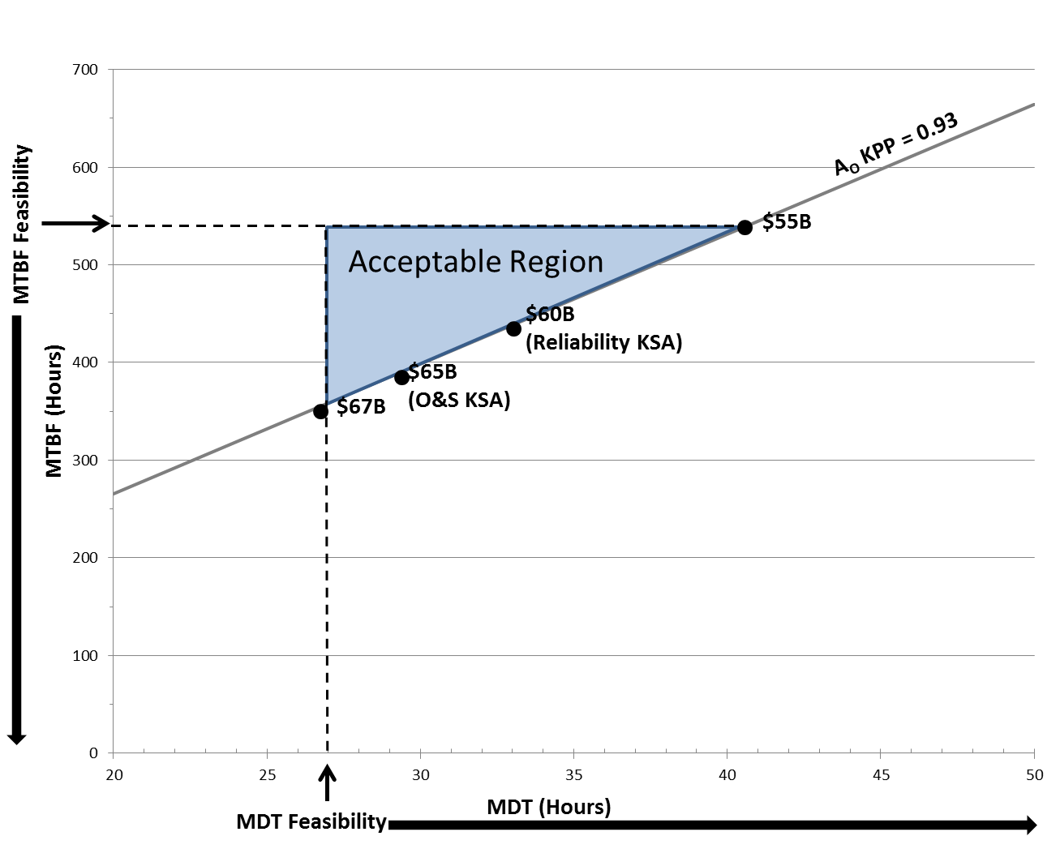
Figure 6-1 Relationship Between Sustainment Parameters and Cost (sample)

Summary
Summarize the results of the RAM-C process. Identify any significant degraders to availability and mission success and the top drivers O&S costs along with any actions in process to mitigate these. Identify any issues with specific sustainment parameters and the recommendations and feedback that have been provided to the requirements developers.
Expectation: At the completion of the RAM-C process, all the thresholds should have been validated and aligned to support Ao, A_{M}, O&S costs, and mission success requirements. The thresholds should be feasible and consistent with the state of the art and technical maturity. The sustainment parameters should be balanced to support Ao and O&S costs.

Appendix A – Acronyms

Provide a list of the acronyms used in the report.

ACAT | Acquisition Category
ALDT | Administrative and Logistics Delay Time
A_{O} | Operational Availability
AoA | Analysis of Alternatives
A_{M} | Materiel Availability
APA | Additional Performance Attribute
BIT | Built In Test
CAPE | Cost Assessment and Program Evaluation
CDD | Capability Development Document
CONEMP | Concept of Employment
CONOPS | Concept of Operations
CPD | Capability Production Document
CRO | Combat Replenishment Operation
FD/SC | Failure Definition/Scoring Criteria
ICD | Initial Capability Document
JCIDS | Joint Capability Integration Development System
KPP | Key Performance Parameter
KSA | Key Supporting Attribute
LCSP | Life Cycle Support Plan
MCT | Mean Corrective Time
MDT | Mean Down Time
MLDT | Mean Logistics Delay Time
MS | Milestone
MFHBF | Mean Flight Hours Between Failure
MFHBOMF | Mean Flight Hour Between Operational Mission Failure
MMH/FH | Maintenance Man Hours per Flight Hour
MTBF | Mean Time Between Failure
MTTR | Mean Time To Repair
O&S | Operating and Support
OMS/MP | Operational Mode Summary/Mission Profile
OSD | Office of the Secretary of Defense
R&M | Reliability and Maintainability
RAM-C | Reliability, Availability, Maintainability, and Cost
RFP | Request For Proposal
SEP | Systems Engineering Plan
SRO | Sustainment Replenishment Operation
TAT | Turn Around Time
TMRR | Technology Maturation and Risk Reduction
WUC | Work Unit Code

Appendix B – Documentation, References, and Tools
Documentation - List the program documents with date and version number in Table B-1. Note relevant sections of the document that were used to develop the RAM-C rationale.
Table B-1 Resource Documents (sample documents)
Document | Date/Version | Relevant Sections to RAM-C
CDD
CONOPs
OMS/MP
AoA Study Plan
AoA Guidance
AoA Report
Acquisition Strategy
SEP
LCSP
Etc.
Expectation: Program should list program documentation sources that were used in the RAM-C process. Relevant sections of each provide a quick and easy understanding of source material.
References – Program should list all sources and references for calculations, policy, and any other analysis used to develop the RAM-C rationale.
Tools – In Table B-2, identify the tools the program plans to use in the RAM-C process.
Table B-2 RAM-C Tools
Tool | Purpose

Appendix C – Composite Model Details
Table C-1 Composite Model Details (Sample aviation WUC)
 | Reliability¹ |  | Maintainability |  | Total Downtime (MDT) | O&S Costs  (3.0)
Subsystem  (2-Digit WUC) | Mission Reliability  (MFHBA) | Logistics Reliability  (MFHBF) | Maintenance Burden (MMH/FH) | Corrective Maintenance  (MTTR)
11 Airframes
12 Furnishings
13 Landing Gear
14 Flight Control/Lift System
15 Hydraulic Propellers
22 Engine
List Remaining subsystems
Assessed System²
JCIDS Threshold
Legacy System³
Notes
1. Use appropriate life units (hours, miles, cycles, etc.)
2. Highlight any cell in red if the assessed system value does not meet the JCIDS Threshold.
3. If applicable, enter legacy system data for each sustainment parameter.

